**Plays and playbooks:**

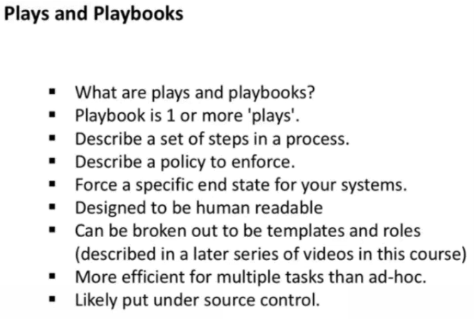

* Play is nothing but an activity
* We use modules in play



* We can execute the basic yml file as below. Create a file with “.yml” extension

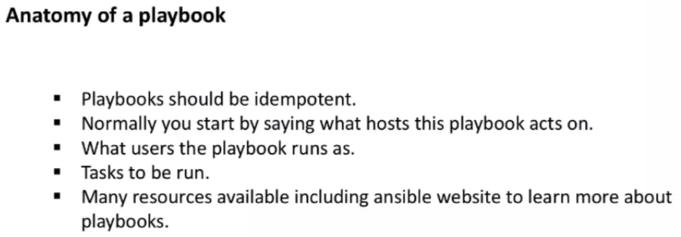

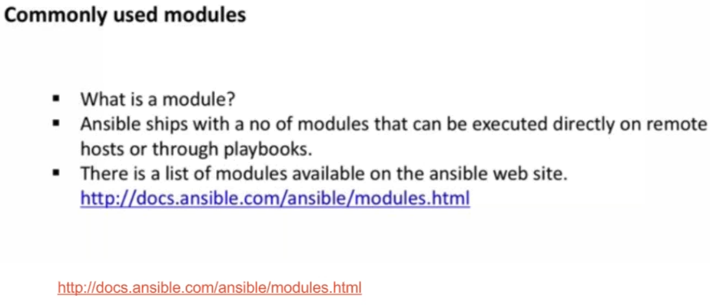

* Module is unit of work

**Commonly used modules:**

**Ping module:**

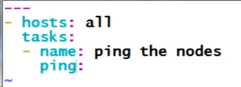

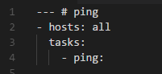

* Run it as below
* **Ansible-playbook <path>/filename.yml**
* We can also specify the hosts as below also



* Below is how we configure yaml file if we want to execute the group of nodes

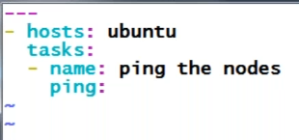

**apt module:**

* If we want to install apache on ubuntu, then the command for that is apt-get install apache2
* To do this with yaml, we need to find the apt module and write yaml file as below

**Examples:**

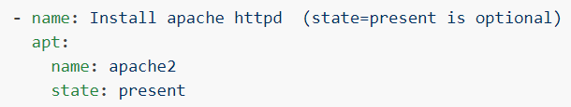

* Even if we don’t add the state as present. Ansible will install httpd

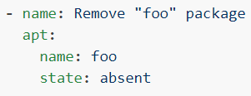

* We can add “absent” as state to remove certain application.

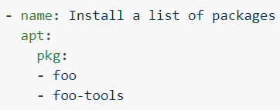

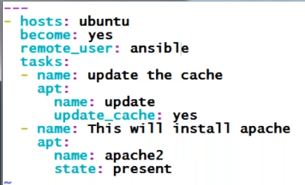

* Installing multiple packages as above.
* As above, we have given sudo permission to ansible to run the script. No need to give remote_user there

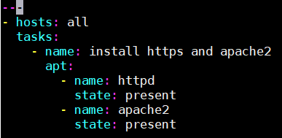

* Above one is not accepting by ansible

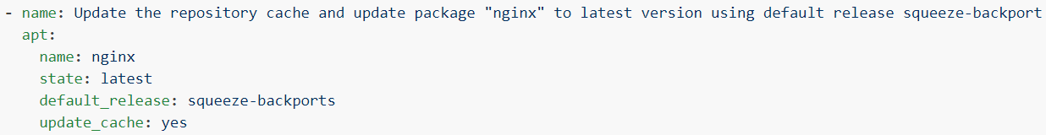

* Update_cache is used to the “apt-get update”. As above, we are updating the cache and installing the latest version of nginx as well.

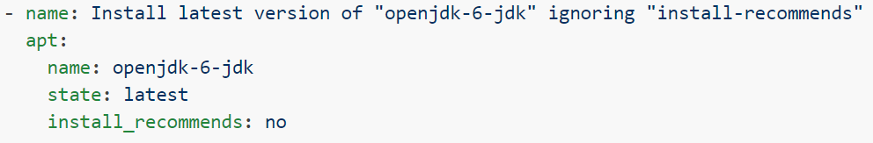

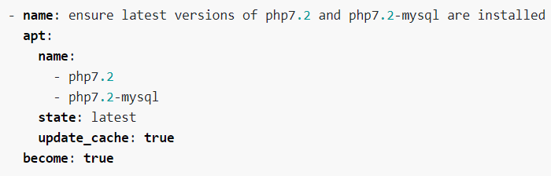

* Installing or updating the packages to latest as above.

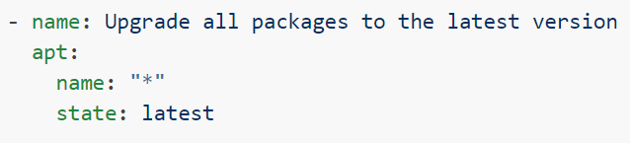

* Updating all the packages to latest.

**Options:**

**force**

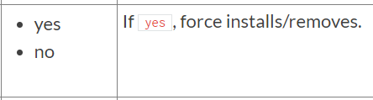

* It is “no” by default.

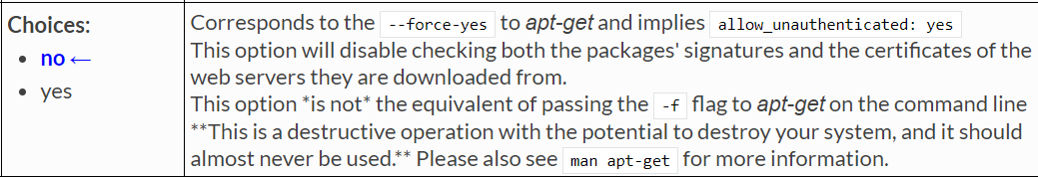

**name**

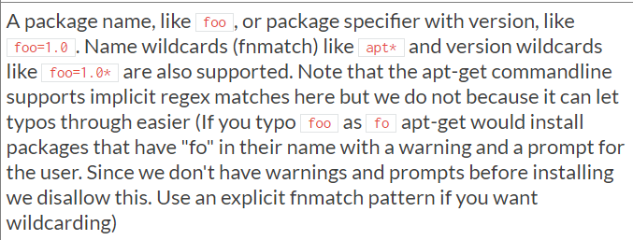

**only_upgrade**



* Default it is **“no”**

**State**

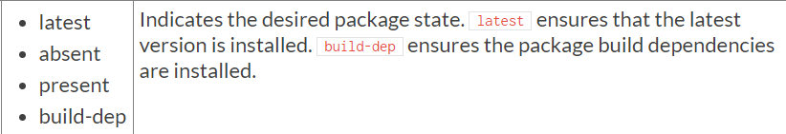

* By default, the value is **“present”**

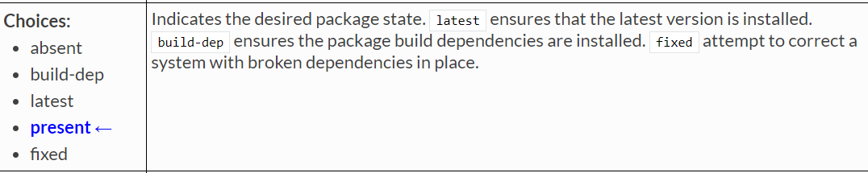

**update_cache**

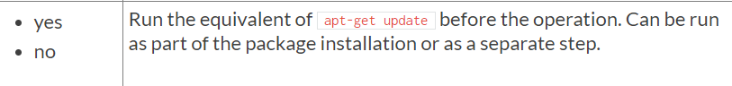

* **“No”** value by default.

**httpd installation and start service:**

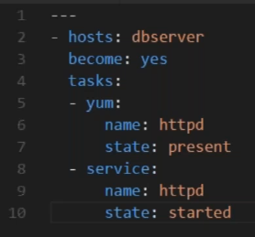

* Give the name of service in name section
* **Ansible-playbook filename.yml -K**
* Suppose we stopped the service manually and execute the yml file again. It checks the state of service and starts it only as the service was already installed so it won’t touch that. It maintains idempotence

**Tomcat installation yml file:**

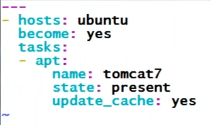

* It is always better to try the task once manually, if it works, then go, write yml file

**Passing -k in ansible command:**

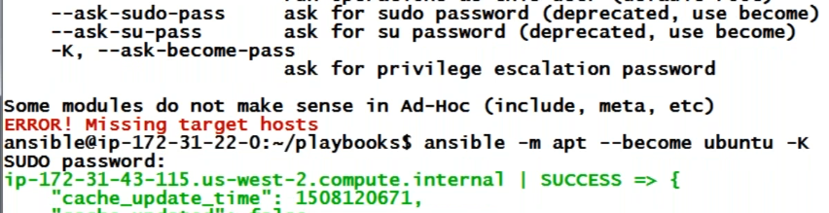

* We need to use -k for privileged execution
* if the first task fails, second one won’t get executed

**yum module:**

* yum module is also almost same as apt but there are few differences.

**Options:**

**name**

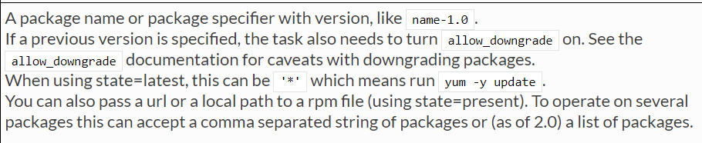

* **“name”** option is same as apt.

**download_dir**

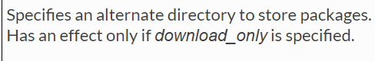

**download_only:**

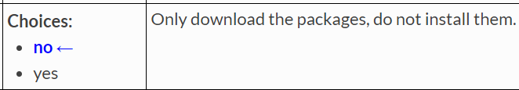

**state**

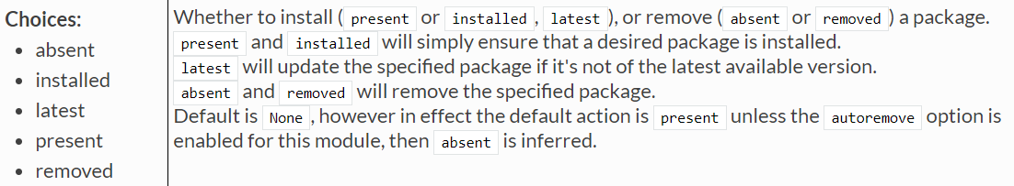

**update_cache**

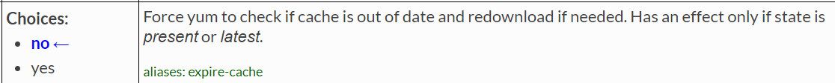

**update_only**

